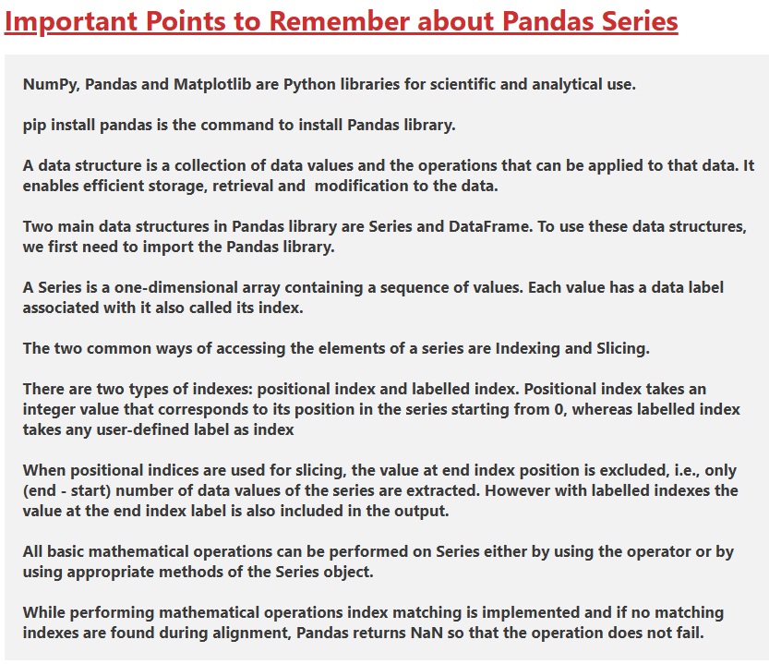

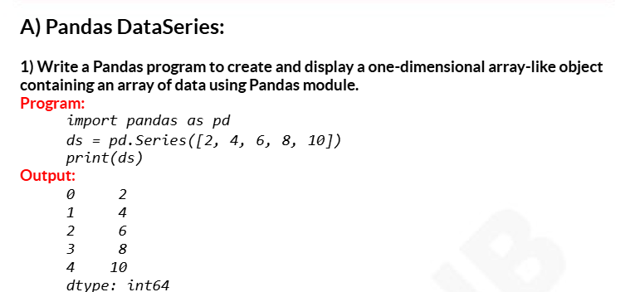

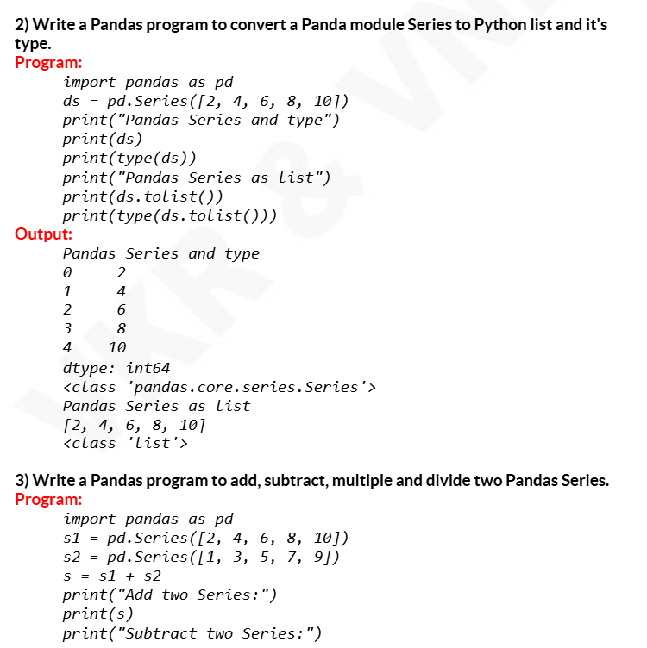

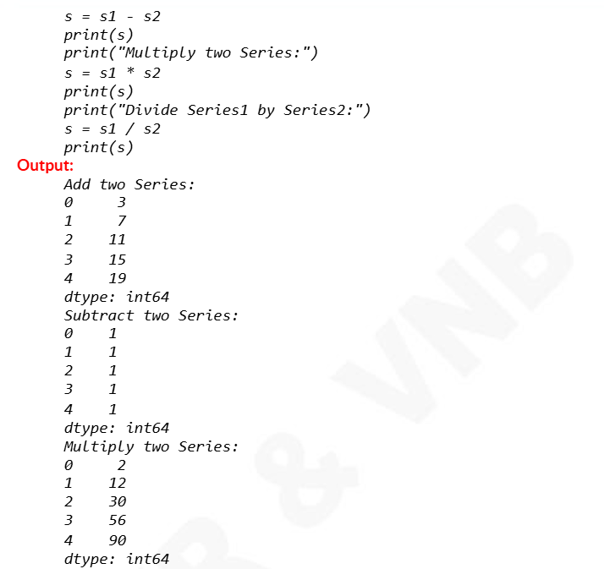

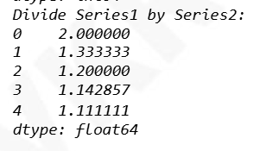

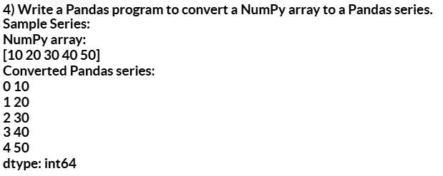

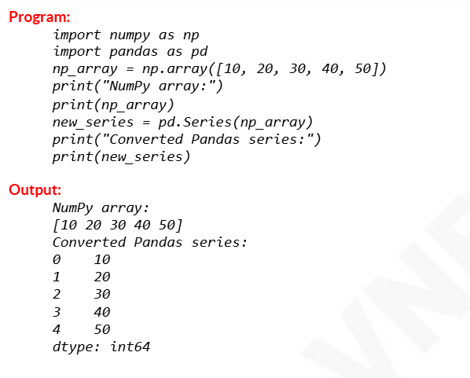

1.Write a program to create a series of vowels.

2. Write a program to create a series of given tuple:a=(11,22,33,44,55)

3. Write a program to create a series of all characters in the name accepted from user.

4. Write a program to create a series from the given dictionary

D={“Jan”:31, ”Feb”:28, ”March”:31, “April”:30, ”May”:31, ”June”:30, “July”:31, ”Aug”:31, ”Sep”:30, “Oct”:31, ”Nov”:30, ”Dec”:31}.

5. Write a program to create a series from the dictionary that stores classes(6,7,8,9,10) as keys and number of students as values.

6. Write a program to modify the value 5000 to 7000 in the following series:

**A 25000**

**B 12000**

**C 8000**

**D 5000**

7.Write a program to display only those values greater than 200 in the given series.

0 300

1 1200

2 1700

3 100

Note: Kindly prefer the PPT named L2 for installation of Pandas. Use IDLE for execution.